Patient & Family Experience Survey
2020/21 Key takeaways
Contents

Introduction 3
Results 5
Response Rate 6
Our Services 6
Our Staff 7
Our Facilities 7
Quality of Care 8
Recommending Friends & Family 9
Giving Feedback/Raising Concerns 9
Evaluation 12
Related Regulations 12
Appendix 1 - Patient Experience Survey 13
Appendix 2 - Family Experience Survey 15

Introduction

3

Getting User Feedback

It is the policy of Keech Hospice Care to listen to, act upon and value the feedback received from any and all stakeholders, whether it be positive or negative, formal, or informal, verbal or written, anonymous or identifiable.

At Keech Hospice Care, service improvement is a continuous and vital aspect of providing the best care our patients can possibly receive. Feedback from those who use our services allows an insight and understanding of our current services, and how they may be improved in the future. The Hospice collects these views in many ways, for instance:
- A ‘Comments, Compliments and Complaints’ leaflet is made available in all patient areas. We review all responses received, treating them as learning and improvement opportunities.
- Quarterly inspections conducted by the Trustees and the Clinical Director which include consultation with patients, families, volunteers, and staff.
- Individual patients or patient groups (rather than focus groups) may be consulted periodically to have input into service developments, information literature, etc. This includes youth engagement or ‘Keech Can’ as identified by the young people.
- PLACE surveys
- Care Safety week
Furthermore, Experience Surveys (including the ‘Friends and Family Test’) for patients, families and carers are carried out throughout the year. These are sent to service users who have received 6 episodes of care. Surveys are sent out monthly to ensure as many patients and family members have an opportunity to give their feedback as possible. A copy of the surveys is included in the appendix.
Throughout the year (April 2020 - March 2021), surveys were sent out to all Keech Hospice Care service users who received 6 episodes of care between the timeframe (excluding any patients considered too poorly to receive a questionnaire). A prepaid response envelope was provided with all surveys.
The survey was updated in December 2021 to incorporate a section on the digital support we offer as well as asking if patients and families are aware of the services we offer.

Results
What were the user’s feedback?
5

Response Rate
A total of 354 surveys were delivered over April 2020 - March 2021, out of which 97 were completed and returned. This is a response rate of 27.4%. A breakdown can be seen below.
 | No. of surveys sent out | No. of responses | Response rate
Adult’s | 111 | 36 | 32.4%
Children’s | 243 | 61 | 25.1%
Total | 354 | 97 | 27.4%

Overall we scored:
 | Last 12 Months % Satisfaction
Adult Service | 96%
Children’s Service | 99%

Our Services

Our Staff
1 adult service user indicated that they ‘Disagreed’ with one of the comments. Throughout the survey they indicated that they ‘Disagreed’ or ‘Agreed’ with a number of questions and made this comment at the end “The pandemic instantly shut down support. By the time I was contacted again the advice was 2+ months out of date and useless. I had to work my physiotherapy all out myself. Learning to walk & function again.” Their survey was anonymous, so we have not been able to contact them. (Survey ID A206)
Our staff are caring
You can talk to our staff about any problems you may be having
Our staff respect your confidentiality at all times
Our staff treat you and your family with dignity and respect at all times
Our staff are friendly and approachable

Our Facilities
The quality of food we provide is good
The standard of cleaning is good throughout the hospice
The Hospice building is a welcoming and comfortable environment

Quality of Care
- Religious/Cultural needs: One family disagreed with this and made a comment regarding better offer of Halal food (Survey ID C129), they responded positively in all other areas of the survey.
- Satisfaction with quality of care provided: One patient from the adult service indicated they ‘Strongly Disagreed’ with this statement (Survey ID A206).
- Personal needs have been assessed: One patient from the adult service indicated they ‘Strongly Disagreed’ with this statement (Survey ID A206).
- Involvement in discussions about care: One family disagreed with this and commented “stop complying to this tyranny. It's a scam, do your own research.” (Survey ID C127), they responded positively in all other areas of the survey.

Your personal needs have been assessed to ensure you get safe and appropriate care
Your cultural/religious needs are met
You are satisfied with the quality of care you have received/are receiving
Your personal needs have been assessed
Before undertaking any care or treatment you are asked whether or not you agree to it
You have been given support to make decisions
You have been involved in discussions about your care, treatment and support

Digital Support
- Satisfied with overall support received during pandemic: One patient from the adult service indicated they ‘Strongly Disagreed’ with this statement (Survey ID A206) and 1 family from the children’s service indicated they ‘Disagreed’ with this statement (Survey ID C131); this family felt we were particularly good with 1-1 play activities but would like to be made aware of the groups that they could attend.
- Kept informed regarding changes to service: One patient from the adult service indicated they ‘Disagreed’ with this statement (Survey ID A206)
- Digital support was beneficial: One patient from the adult service indicated they ‘Disagreed’ with this statement (Survey ID A203), this person did not provide any further comment other than “you treated me as a person, not just a number”
- Access to telephone support as required: One patient from the adult service indicated they ‘Strongly Disagreed’ with this statement (Survey ID A206).
- Trouble accessing digital services: This question had 18 responses, 76% of our service users said they did not have trouble accessing digital services.

You are satisfied overall with the support you have received during the pandemic
You were kept informed regarding changes to the service
You find digital support beneficial
You have access to telephone support as required
You have had trouble accessing digital services

Recommending Friends & Family
One patient from the adult service indicated they were ‘Extremely Unlikely’ to recommend our services to their family and friends (Survey ID A206) as did one family from the children’s service (Survey ID C137), in their responses they indicated that they were satisfied with our staff but answered N/A in all other sections.

Giving Feedback/Raising Concerns

If you needed to make a complaint or raise a concern you would feel confident in doing so

What do you think Keech does particularly well?
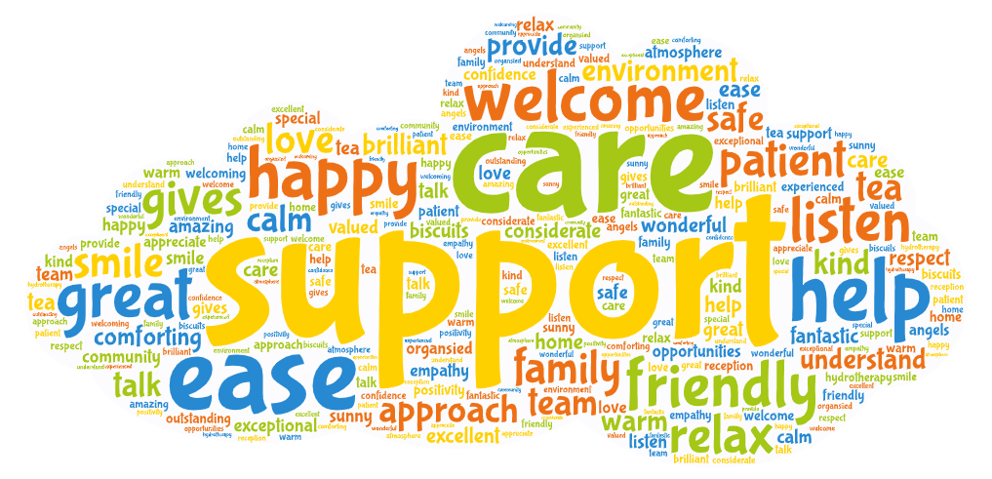

We received 27 comments regarding the great support and care we provide, some examples are:
- “Thinking of not only the patient but the family as well. The care is amazing.”
- “Very kind and caring. Treat my mum with the utmost respect, engaging appropriately with her (due to dementia) - care is very person centred.”
- “The way the staff treat you, gives you a feeling of confidence and pride in your treatment. Thank you.”

We received 14 comments regarding the friendly, welcoming staff and environment, some comments are highlighted below:
- “Everyone has been so welcoming, supportive and caring. I cannot praise Keech Hospice high enough. Thank you.”
- “Provides a warm, welcoming, friendly environment for the whole family. Supportive, understanding, caring staff.”
- “Everyone had a smile for me, nobody rushes you, staff really listen to what you have to discuss. I am eternally grateful for all support.”
- “Made to feel welcoming, felt safe that volunteers and staff knew what they were doing.”

We received 6 comments regarding how staff communicate and listen to patients:
- “They kept in contact with us throughout the Covid lockdown even though we were infrequent users.”
- “They are very kind and understanding and take their time and not hurry and listen to what I say.”
- “Gives friendly chats and support.”

We received 6 general comments such as:
- “They lift my hope up every time I am there.”
- “Happy in all aspects.”
- “Thank you very much as an individual.”

Is there anything we could improve on?
22 responses were received for this question. Most responses were positive, with a lot of compliments such as “No, very pleased with the service provided”, “Nothing! I can't come anymore because we have moved out of area (Bedford)” and “It's very difficult to improve on what I feel is perfection”. Comments suggesting possible improvements have been noted below:
Comment | Our Response
“Promised that somebody would collect and return to home. Family member had to do it and wait, hardly a respite.” | Prior to the Covid 19 pandemic, we were fortunate to have a group of volunteer drivers available, who offered their service to us regularly to pick up patients from and return them to their home following their appointment. This was primarily for patients who had no other means of attending the hospice, such as a family member, but where capacity allowed, this was extended to other groups of patients.  When the pandemic took hold, many of our volunteers were required to shield or minimise contact for their own protection and were therefore not available to drive for us. We also closed our outpatient services to all but absolutely essential clinical appointments where support could not be achieved any other way. As we start to bring these outpatient services back, albeit in a reduced capacity, the safety of our patients, their families and our staff remains our priority. This also means reducing contact as far as possible, so where patients that need to attend have someone that can bring them, this is preferable and is encouraged. At this time, we still have limited volunteer drivers available and therefore this support is offered on a priority basis, following careful patient assessment.
“More organised fitness groups in pool.” | The Hydrotherapy pool is used for therapeutic purposes rather than fitness. Patients can also be referred to the Aquatic Physiotherapist and there is potential for this to be conducted in groups. The Hydrotherapy pool closed in March 2020 due to Covid-19 and has reopened in October 2020 with very limited use in line with Swim England and government guidelines. There are currently no thoughts on any kind of groups in the Hydrotherapy pool.
“Accessibility to Hydrotherapy pool.” | After speaking to the family, it was because they wanted to access the pool after school hours. Unfortunately, we do not have resources to open the pool after hours, and other users hire the facility after hours. I explained this to the family, and they said that their daughter is now able to access other public pools.
“More communication and treatments for complementary therapies.” | Complementary therapies were suspended during 2020 as these are offered by volunteers and due to Covid-19 restrictions, the volunteer therapists were asked to stand down. Keech was working towards introducing an amended complementary therapy service towards the end of 2020, but once again tighter restrictions prevented this from going ahead. It is hoped that a service can be re-commenced in the next couple of months, subject to government guidance.
“More respite visits.” | Families do have the option to request short breaks at the hospice of up to three nights. Due to staffing levels we are generally only able to accommodate one, or on occasion, two children at a time. We are hoping to increase the availability of short breaks at weekends later this year. Families will be kept informed through the newsletter and their community contact.
“The pandemic instantly shut down support. By the time I was contacted again the advice was 2+ months out of date & useless. I had to work my physiotherapy all out myself. Learning to walk & function again.” | Throughout the pandemic, we have complied with the national lock down requirements issued by the Government, and this unfortunately resulted in our outpatient services being severely restricted. However, we have continued to support patients through telephone contact and virtual sessions wherever possible. With the introduction of the Government’s recovery road map, we will be able to restart more of our services in a phased approach and in line with the guidance issued at each step.
“Yes, stop complying to this tyranny. It's a scam, do your own research.” | We are working within Government guidelines to provide a safe service.
“Offer halal food.” | I am sure that with discussion with our catering department we would be able to offer Halal food. We currently only offer halal chicken and have vegetarian options.
“Being made aware of groups we can attend.” | The newsletter, community team contact and Play team can advise on groups although most activities have been provided virtually over the last year. We are hopeful that as Covid restrictions lift we will be able to increase the range of activities and the appointment of a Play and Activities Coordinator last year will support the development of access to activities in the community.

Evaluation
Responses to this survey were generally excellent and extremely complimentary about the experiences with Keech Hospice. There were lots of positive feedback and some great suggestions for improvements. This survey allows the Hospice to identify any area or service that impact on the quality of care for a patient (or their friend/family).

Related Regulations
Care Quality Commission (CQC) Regulation 17e Good Governance:
“seek and act on feedback from relevant persons and other persons on the services provided in the carrying on of the regulated activity, for the purposes of continually evaluating and improving such services.”

Appendix 1 - Patient Experience Survey
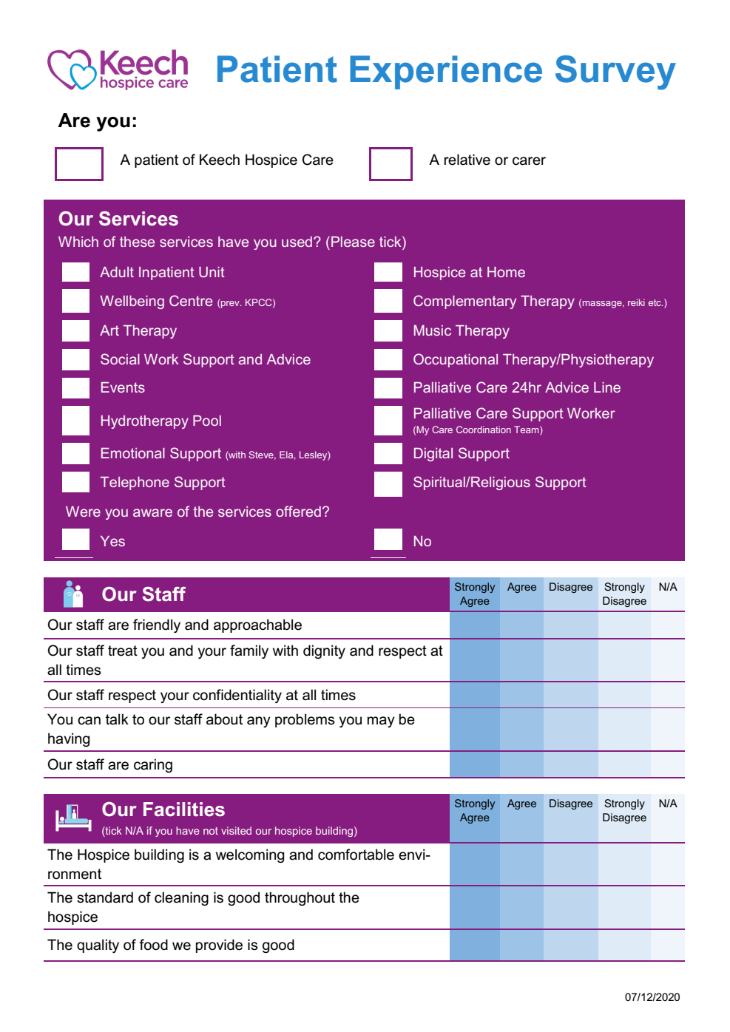

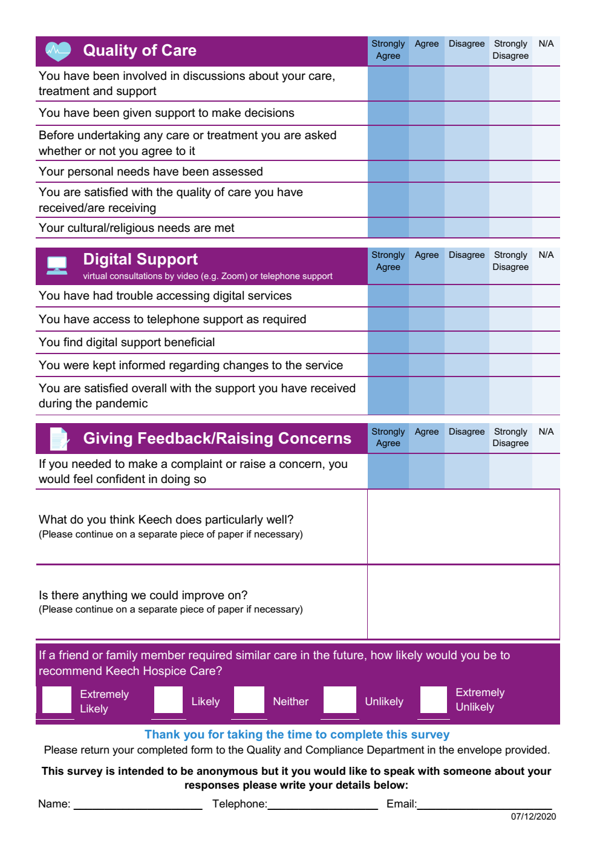

Appendix 2 - Family Experience Survey
